主题：贫困家庭

题型：表格

The table below shows the proportion of different categories of families living in poverty in Australia in 1999.

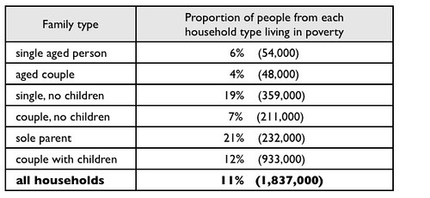

满分范文：  
  
The table gives information about poverty rates among six types of household in Australia in the year 1999.  
  
It is noticeable that levels of poverty were higher for single people than for couples, and people with children were more likely to be poor than those without. Poverty rates were considerably lower among elderly people.  
  
Just over one fifth of single parents were living in poverty, whereas only 12% of parents living with a partner were classed as poor. The same pattern can be seen for people with no children: while 19% of single people in this group were living below the poverty line, the figure for couples was much lower, at only 7%.

Overall, 11% of Australians, or 1,837,000 people, were living in poverty in 1999. Aged people were the least likely to be poor, with poverty levels of 6% and 4% for single aged people and aged couples respectively.